MASS Java Manual
  - August 31, 2016

Intro
This document is written to define the third draft version of the MASS library, a parallel-computing library for Multi-Agent Spatial Simulation. As envisioned from its name, the design is based on multi-agents, each behaving as a simulation entity on a given virtual space. The library is intended to parallelize a program that particularly on multi-entity interaction in physical, biological, social, and strategic domains. The examples include major physics problems (including molecular dynamics, Schrödinger’s wave equation, and Fourier’s heat equation), neural network, artificial society, and battle games.

Table of Contents
1. Intro 1
2. Table of Contents 1
3. Programming Model 1
3.1. Components: Places and Agents 1
3.2. Programming Framework 2
4. MASS 3
5. Places 5
5.1. Class Places 5
5.2. Class Place 8
5.3. callMethod 9
5.4. Example 1: Wave2D 10
6. Agents 12
6.1. Class Agents 13
6.2. Class Agent 15
6.3. Example 2: RandomWalk 17
7. Debugger 19
7.1. User Application Changes 20
7.2. Debugger GUI 21

Programming Model

Components: Places and Agents
Places and Agents are keys to the MASS library. Places is a matrix of elements that are dynamically allocated over a cluster of computing nodes. Each element, called a Place, is pointed to by a set of network-independent matrix indices, and is capable of exchanging information with any other Place. On the other hand, Agents is a set of execution instances that can reside on a place, migrate to any other Place with matrix indices, (thus as duplicating themselves), and interact with other Agents as well as multiple Places.

An example of Places and Agents in a battle game could be territories and military units respectively. Some applications may need only either Places or Agents. For instance, Schrödinger's wave simulation needs only two-dimensional places, each diffusing its wave influence to the neighbors. Molecular dynamics needs only agents, each behaving as a particle since it must collect distance information from all the other particles for computing its next position, velocity, and acceleration.

Parallelization with the MASS library assumes a cluster of multi-core computing nodes as the underlying computing architecture, and thus uses a set of multi-threaded communicating processes that are forked over the cluster and managed under the control of typical message-passing software infrastructure such as sockets and MPI. The library spawns the same number of threads as that of CPU cores per node or per process. Those threads take charge of method call and information exchange among places and agents in parallel.

Places are mapped to threads, whereas Agents are mapped to processes. Unless a programmer indicates his/her places-partitioning algorithm, the MASS library divides Places into smaller stripes in vertical, or in the X-coordinate direction, each of which is then allocated to and executed by a different thread. Contrary to Places, Agents are grouped into bags, each allocated to a different process where multiple threads keep checking in and out one after another Agent from this bag when they are ready to execute a new Agent. If Agents are associated with a particular Place, they are allocated to the same process whose thread takes care of this Place.
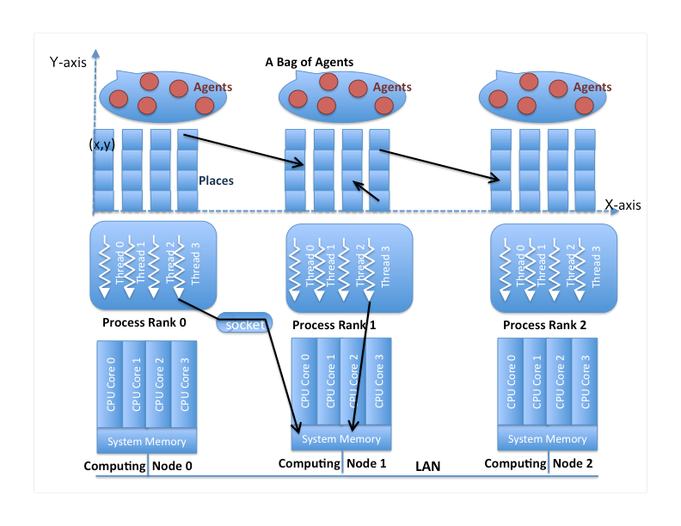

Programming Framework
The following code shows a Java programming framework that uses the MASS library to simulate a multi-agent spatial simulation.

- import edu.uw.bothell.css.dsl.MASS*;

- class Application {

- public void static main( String[] args ) {
- // get the max simulation time
- int maxTime = Integer.parseInt( args[0] );

- // start a process at each computing node
- MASS.init();

- // distribute places and agents over computing nodes
- Places territories
- = new Places( 1, "Territory", null, 100, 100 );
- Agents troops
- = new Agents( 2, "Troop", null, territories, 40000 );

- // start cyclic simulation in parallel
- int[] destination = new int[2]; dest[0] = 0; dest[1] = 1;
- for ( int time = 0; time < maxTime - 10; time++ ) {
- Object arg = ( Object )( new Integer( time ) );
- territories.callAll( Territory.compute_, arg );
- territories.exchangeAll( 1, Territory.exchange_, dest );
- troops.callAll( Troop.compute_, arg );
- troops.manageAll();
- }

- // terminate the processes
- MASS.finish();
- }
- }

The behavior of the above code is as follows: it synchronizes all processes with MASS.init() and has them spawn multiple threads (line 10). The code thereafter maps a matrix of 100 × 100 “Territory” places as well as 4000 “Troop” agents over these processes (lines 13 – 16). Each process falls into a cyclic simulation (lines 20 – 26) where all its threads repeat calling the following three functions in a parallel fashion:
    - compute() of the “Territory” places to update each place object’s status
    - exchange() of the “Territory” places to exchange data among place objects
    - compute() of the “Troop” agents to update each agent’s status
as well as control the “Troop” agents in manageAll() so as to move, spawn, terminate, suspend, and resume agents. At the end, all the processes get synchronized together for their termination with MASS.finish() (line 29).

In the following sections, we will define the specification of MASS, Place, Place, Agents, and Agent.

MASS
All processes involved in the same MASS library computation must call MASS.init() and MASS.finish() at the beginning and end of their code respectively, so as to get started and finished together. Upon a MASS.init() call, each process, running on a different computing node, spawns the same number of threads as that of its local CPU cores, so that all threads can access places and agents. Upon a MASS.finish() call, each process cleans up all its threads as being detached from the Places and Agents objects.

MASS Method Detail
init
public static void init()

Initialize the MASS library (using settings declared in “nodes.xml”). Calling this method effectively begins computation. Use this init when the nodes and other MASS settings are defined in nodes.xml

finish
public static void finish()

Finish computation, terminate remote processes, and perform cleanup and disconnection operations. This method should be called when all computational work has been completed.
setNodeFilePath
public static void setNodeFilePath( String nodeFilePath )

Set the filename for the cluster node definition file. Use this function if the nodes are defined in an xml file not named “nodes.xml”.

Parameters:
String nodeFilePath – Directory of the xml file containing the nodes definition.
debugInit
public void debugInit( int placesHandle, int agentsHandle, int port )

Starts the debugger and waits to connect to the GUI on the provided port. This function will block the application until the GUI has connected, allowing the GUI and the debugger application to be executed in any order. After a connection is made some initial data about the Places and Agents are sent to the GUI. See section 7.1.1.

Parameters:
int placesHandle – User defined handle of the Places object they wish to debug.
int agentsHandle – User defined handle of the Agents object they wish to debug.
int port – Port with which the user wishes to connect the debugger to.
debugUpdate
public void debugUpdate()

This method is used to update the information in the debugger. Should be called at the end of the cyclic simulation loop. See section 7.1.1.
setNumThreads
public static void setNumThreads( int numThreads )

Set the number of threads to spawn on each node.

Parameters:
int numThreads – The number of threads to spawn.

Places
Places is a distributed matrix whose elements are allocated to different computing nodes. Each element, (termed a Place) is addressed by a set of network-independent matrix indices. Once the main method has called MASS.init(), it can create as many Place objects as needed, using the Places constructor. Unless a user supplies an explicit mapping method in their Place definition, a Places instance is partitioned into smaller stripes in terms of coordinates[0], and is mapped over a given set of computing nodes, (i.e., processes).

Class Places
Places manages all Place elements within the simulation space. The class instantiates an array of user-defined Place objects shared among multiple nodes. Array elements are accessed and processed by multi-processes in parallel.

Places Constructor Detail
Places
public Places( int handle, String className, Object argument, int... size )

Instantiates a shared array of Place objects with size from the className class as passing an argument to the className constructor. This array is associated with a user-given handle that must be unique over machines.

Parameters:
int handle – A unique identifier that designates a group of places. Must be unique over all machines.
String className – Name of the user-implemented class Places are constructed from.
Object argument – Arguments for user-defined Place constructor.
int... size – Size of the matrix the user wants to create. Given in varargs form, so users can create a matrix of how many dimensions they want. For example, a 2-dimensional matrix of size 100 would use Places( 1, className, argument, 100, 100 ), while a 3-dimensional matrix of size would use Places( 1, className, argument, 100, 100, 100 ).

Places
Places( int handle, String className, int boundaryWidth, Object argument, int... size )

Instantiates a shared array of Place objects with size from the className class as passing an argument to the className constructor. This array is associated with a user-given handle that must be unique over machines.

Parameters:
int handle – A unique identifier that designates a group of places. Must be unique over all machines.
String className – Name of the user-implemented class Places are constructed from.
int boundaryWidth – The amount of Place objects shared between stripes on different nodes. For example, if there are two computing nodes, sharing 100 Place objects in the x direction and boundaryWidth is set to 5, node 0 will be responsible for the Place objects at x-coordinates 0 – 54 and node 1 will be responsible for the Place objects at 45 – 99. This boundary region can easily be exchanged using Places.exchangeBoundary(). Default is 0.
Object argument – Arguments for user-defined Place constructor.
int... size – Size of the matrix the user wants to create. Given in varargs form, so users can create a matrix of how many dimensions they want. For example, a 2-dimensional matrix of size 100 would use Places( 1, className, 1, argument, 100, 100 ), while a 3-dimensional matrix of size would use Places( 1, className, 1, argument, 100, 100, 100 ).

Places Method Detail
getHandle
public int getHandle()

Returns the handle associated with this array of Place objects.

Returns:
The handle associated with this array.

getSize
public int[] getSize()

Returns the size of this multi-dimensional array.

Returns:
The size of the array of Place objects.

callAll
public void callAll( int functionId )

Calls the user-defined method specified with functionId of all array elements. Done in parallel among multi-processes/threads. To be used when there are no arguments in the user-defined function to be called.

Parameters:
int functionId – The Id of the user-created function to be called from the overridden callMethod() function that is derived from Place. The callMethod() function is detailed in section 5.3.

callAll
public void callAll( int functionId, Object argument )

Calls the user-defined method specified with functionId of all array elements as passing an Object argument to the method. Done in parallel among multi-processes/threads.

Parameters:
int functionId – The Id of the user-created function to be called from the overridden callMethod() function that is derived from Place. The callMethod() function is detailed in section 5.3.
Object argument – Argument passed to the user-defined function.

callAll
public Object[] callAll( int functionId, Object[] arguments )

Calls the user-defined method specified with functionId of all array elements as passing arguments[i] to element[i]’s method, and receives a return value from it into Object[i]. Done in parallel among multi- processes/threads. In case of a multi-dimensional array, i is considered as the index when the array is flattened to a single dimension.

Parameters:
int functionId – The Id of the user-created function to be called from the overridden callMethod() function that is derived from Place. The callMethod() function is detailed in section 5.3.
Object[] argument – Arguments passed to the user-defined function.

Returns:
An array of objects from each Place objects callMethod() return value.

exchangeAll
public void exchangeAll( int destinationHandle, int functionId )

Calls the user-defined method specified with functionId of all destination cells, each indexed with a different Vector element. Each vector element, say destination[] is an array of integers where destination[i] includes a relative index (or a distance) on the coordinate i from the current caller to the callee cell. The caller cell’s outMessage is a continuous set of arguments passed to the callee’s method. The caller’s inMessages[] stores values returned from all callees. More specifically, inMessages[i] maintains a set of return values from the i^{th} callee.

Parameters:
int destinationHandle – The unique identifier defined in the Places constructor for the Places object that is to be interacted with.
int functionId – The id of the user-defined method to call in callMethod().
exchangeBoundary
public void exchangeBoundary()

Exchanges each node’s boundary region with that node’s neighbors. If there was no boundary defined in the Places constructor, then this will do nothing.

Class Place
Place is the base class from which a user can derive an application-specific matrix of Place objects. An actual matrix instance is created and maintain within a Places class, so that the user can obtain parallelizing benefits from Places callAll() and exchangeAll() methods that invoke a given method of each matrix element and exchange data between each element and others.

Method Detail
callMethod
public Object callMethod( int functionId, Object arguments )

Is called from Places.callAll() and Places.exchangeAll(). Invokes the user-created function pointed to by functionId. An application should override callMethod() so as to direct Places to invoke an application-specific method.

Parameters:
int functionId – Id of the user-defined function to call.
Object[] arguments – Arguments passed to the user-defined function.

Returns:
Return value of the user-defined functions.
getAgents
public synchronized Set<Agent> getAgents()

Returns a set containing the Agents that are executing on this Place.

Returns:
A set containing the Agents that are executing on this Place.
getNumAgents
public int getNumAgents()

Returns the number of Agents that are executing on this Place.

Returns:
The number of Agents that are executing on this Place.
getInMessages
public Object[] getInMessages()

Returns the values from this Places neighbors defined in setNeighbors() after an exchangeAll() call.

Returns:
The values from this Places neighbors defined in setNeighbors() after an exchangeAll() call.
setNeighbors
public void setNeighbors( Vector<int[]> neighbors )

Defined the Places relative to this Place that this Place is to look to when exchanging information between Places in exchangeAll().

Parameters:
Vector<int[]> neighbors – The coordinates of Places that are defined to be neighbors if this Place.
getDebugData
public Number getDebugData()

Debugger method that allows the user return the data for this Place so they can view it in the debugger. To be implemented by the user in their Place class. See section 7.1.2.

Returns:
The value the user wants to return for this Place as a Number, a Java class Double, Integer, Byte, etc., are derived from.

setDebugData
public void setDebugData( Number data )

Debugger method that allows the user to inject their own values for this Place in the debugger. To be implemented by the user in their Place class. See section 7.1.2.

Parameters:
Number data – The value to be added to this Place.

callMethod
Since method names are user-given, it is quite natural to invoke each array element’s method through Java reflection, which is intolerably slow for parallel computing. Thus, when deriving from Place, the user should override the callMethod() function to run user made functions. The callMethod() function is a user-provided framework that assists the MASS library in choosing a method to call. The callMethod() function should include a switch statement where each function, is identified by a user-defined integer value. This is shown in the code sample below. The callMethod() is called by the callAll() and exchangeAll() functions in Places to allow all Place objects functions to be called in parallel.

- public class Wave2D extends Place {
- // constants: each array element’s methods are identified by an integer
- // rather than its name.
- public static final int init_ = 0;
- public static final int computeNewWave_ = 1;
- public static final int exchangeWave_ = 2;
- public static final int collectWave_ = 3;
- public static final int startGraphics_ = 4;
- public static final int writeToGraphics_ = 5;
- public static final int finishGraphics_ = 6;

- // automatically called from callAll and exchangeAll.
- // args may be null depending on a calling method.
- public static Object callMethod( int funcId, Object args ) {
- switch( funcId ) {
- case init: return init( args );
- case computeNewWave_: return computeNewWave( args );
- case exchangeWave_: return exchangeWave( args );
- case storeWave_: return exchangeWave( args );
- case startGraphics_: return startGraphics( args );
- case writeToGraphics_: return writeToGraphics( args );
- case finishGraphics_: return finishGraphics( args );
- }
- return null;
- }

- public Object init( Object args ) {
- ...;
- }
- Public Object computeNewWave( Object args ) {
- ...;
- }
- }

Example 1: Wave2D
The following Wave2D class is a two-dimensional matrix that simulates Schrödinger's wave diffusion. Each “Wave2D” matrix element maintains the six instance variables listed below:
wave[2]: The current wave height at each matrix element
wave[1]: The previous wave height
wave[0]: Even the one more previous wave height
neighbor[0]: Through to neighbor[3]: the wave height of north/east/south/west neighbors
time: The current simulation time
interval: Time interval to display the ongoing simulation results

In this Wave2D class, callMethod() maps each functionId to the corresponding function (lines
43 – 52); init() initializes instance variables of each place or cell (lines 68 – 76); computeWave(
) simulates wave diffusion per time unit (lines 78 – 120); exchangeWave() receives wave
heights from all the four neighbors (lines 122 – 125); collectWave() collects wave heights from all places into place[0][0] that then displays them in graphics (lines 127 – 129).

- import edu.uw.bothell.css.dsl.MASS.*;
- // Library for Multi-Agent Spatial Simulation
- // also uses key events so we need this

- public class Wave2DMass {
- public static void main( String[] args ) throws Exception {
- MASS.init( );

- // create a Wave2D array
- Places wave2D = new Places( 1, Area.class.getName(), null, 100, 100 );
- wave2D.callAll( Area.init_ );

- // now go into a cyclic simulation
- for ( int time = 0; time < 500; time++ ) {
- wave2D.callAll( Area.computeWave_, new Integer( time ) );
- wave2D.exchangeAll( 1, Area.exchangeWave_ );
- }

- MASS.finish( );
- }
- }

- public class Area extends Place {
- // constants
- public static final int init_ = 0;
- public static final int computeWave_ = 1;
- public static final int exchangeWave_ = 2;
- public static final int collectWave_ = 3;

- // wave height at each cell
- // wave[0]: current, wave[1]: previous, wave[2]: one more previous height
- double[] wave = new double[3];

- int time = 0;

- // wave height from four neighbors: north, east, south, and west
- private final int north = 0, east = 1, south = 2, west = 3;
- double[] neighbors = new double[4];

- // simulation constants
- private final double c = 1.0; // wave speed
- private final double dt = 0.1; // time quantum
- private final double dd = 2.0; // change in system

- // the array size and my index in (x, y) coordinates
- private int sizeX, sizeY;
- private int myX, myY;

- public Area( Object args ) {
- Vector<int[]> placeNeighbors = new Vector<int[]>();
- placeNeighbors.add( new int[] { 0, -1 } );
- placeNeighbors.add( new int[] { 1, 0 } );
- placeNeighbors.add( new int[] { 0, 1 } );
- placeNeighbors.add( new int[] { -1, 0 } );
- setNeighbors( placeNeighbors );
- }

- public Object callMethod( int funcId, Object args ) {
- switch( funcId ) {
- case init_: return init( args );
- case computeWave_: return computeWave( args );
- case exchangeWave_: return ( Object )exchangeWave( args );
- case collectWave_: return ( Object )collectWave( args );
- }
- return null;
- }

- public Object init( Object args ) {
- sizeX = getSize()[0]; sizeY = getSize()[1]; // size is the base data members
- myX = getIndex()[0]; myY = getIndex()[1]; // index is the base data members

- // reset the neighboring area information.
- neighbors[north] = neighbors[east] = neighbors[south] = neighbors[west] = 0.0;

- return null;
- }

- public Object computeWave( Object arg_time ) {
- // retrieve the current simulation time
- time = ( ( Integer )arg_time ).intValue( );

- // move the previous return values to my neighbors[].
- if ( getInMessages() != null ) {
- for ( int i = 0; i < 4; i++ ) {
- if (getInMessages()[i] != null){
- neighbors[i] = ( ( Double )getInMessages()[i] );
- }
- }
- }

- if ( myX == 0 || myX == sizeX - 1 || myY == 0 || myY == sizeY ) {
- // this cell is on the edge of the Wave2D matrix
- if ( time == 0 ) wave[0] = 0.0; //current
- if ( time == 1 ) wave[1] = 0.0; //previous
- else if ( time >= 2 ) wave[2] = 0.0; //previous2
- } else {
- // this cell is not on the edge
- if ( time == 0 ) {
- // create an initial high tide in the central square area
- wave[0] = ( sizeX * 0.4 <= myX && myX <= sizeX * 0.6 &&
- sizeY * 0.4 <= myY && myY <= sizeY * 0.6 ) ? 20.0 : 0.0;
- //start w/ wave[0]
- wave[1] = wave[2] = 0.0; // init wave[1] and wave[2] as 0.0
- } else if ( time == 1 ) {
- // simulation at time 1
- wave[1] = wave[0] + c * c / 2.0 * dt * dt / ( dd * dd ) *
- ( neighbors[north] + neighbors[east] + neighbors[south] +
- neighbors[west] - 4.0 * wave[0] ); //wave[1] based on wave[0]
- } else if ( time >= 2 ) {
- // simulation at time 2 and onwards
- wave[2] = 2.0 * wave[1] - wave[0] + c * c * dt * dt / ( dd * dd ) *
- ( neighbors[north] + neighbors[east] + neighbors[south]
- + neighbors[west] - 4.0 * wave[1] );
- //wave two based on wave[1] and wave[0]
- wave[0] = wave[1]; wave[1] = wave[2];
- //shift wave[] measurements, prepare for a new wave[2]
- }
- }
- return null;
- }

- public Double exchangeWave( Object args ) {
- return new Double( ( ( time == 0 ) ? wave[0] : wave[1] ) );
- //wave one used after start
- }

- public Double collectWave( Object args ) {
- return new Double( wave[2] );
- }
- }

Agents
Agents are a set of execution instances made up of user-defined Agent objects. Each is capable of residing on a place, migrating to any other Place objects with matrix indices, and interacting with other agents as well as multiple Places.

Class Agents
Once the main method has called MASS.init(), it can create as many Agent objects as needed, using the Agents constructor. Unless a user supplies an explicit mapping method in their Agent definition (see 6.2 Class Agent), Agents distribute instances of a given Agent class uniformly over different computing nodes.

Agents Constructor Detail
Agents
public Agents( int handle, String className, Object argument, Places places, int initPopulation )

Instantiates a set of Agent objects from the className class, passes the argument object to their constructor, associates them with a given Place matrix, and distributes them over these places, based the Agents.map() method that is defined within the Agent class. If a user does not overload it by themselves, Agents.map() uniformly distributes an initPopulation number of Agent objects. If a user-provided Agents.map() method is used, it must return the number of Agent objects spawned at each Place regardless of the initPopulation parameter. Each set of Agent objects is associated with a user-given handle that must be unique over all machines.

Parameters:
int handle – A unique identifier that designates a group of Agent objects. Must be unique over all machines.
String className – The name of the user-defined class to instantiate
Object argument – The argument to pass to each Agent as it is being instantiated
Places places – The Places instance that will contain the Agents
int initPopulation – The number of Agent Objects to create.

Agents Method Detail

getHandle
public int getHandle()

Returns the handle associated with this Agent set.

Returns:
Unique handle for this Agent set.

nAgents
public int nAgents()

Returns the total number of Agent objects in this set.

Returns:
Total number of Agent objects in this set.

callAll
public void callAll( int functionId )
Calls the user-defined method specified with functionId of all Agent objects in this this collection. Done in parallel among multi-processes/threads. To be used when there are no arguments in the user-defined function to be called.

Parameters:
int functionId – The Id of the user-created function to be called from the overridden callMethod() function that is derived from Agent. This callMethod() function is similar to the one defined in Places and detailed in section 5.3.

callAll
public void callAll( int functionId, Object argument )

Calls the method specified with functionId of all agents as passing an Object argument to the method. Done in parallel among multi-processes/threads.

Parameters:
int functionId – The Id of the user-created function to be called from the overridden callMethod() function that is derived from Agent. The callMethod() function is similar to the one defined in Places and detailed in section 5.3.
Object argument – Argument passed to the user-defined function.

manageAll
public void manageAll()

Updates each agent’s status, based on each of its latest migrate(), spawn(), and kill() calls. These methods are defined in the Agent base class and may be invoked from other functions through callAll. Done in parallel among multi-processes/threads.

The following example of code fragment creates a size x size matrix over multiple processes (line 10), distributes a “RandomWalk” agent every four places of this matrix (lines 11 – 12), and simulates random walk of these agents over the matrix using many threads (lines 13 – 17).
- import MASS;

- class RandomWalkDriver {
- public void static main( String[] args ) {
- MASS.init();

- int size = Integer.parseInt( args[0] );
- int maxTime = Integer.parseInt( args[1] );

- Places matrix = new Place( 1, "Matrix", null, size, size );
- Agents walkers =
- new Agents( 2, "RandomWalk", null, matrix, size * size / 4 );
- for ( int time = 0; time < maxTime; time++ ) {
- walkers.callAll( RandomWalk.newLocation );

- walkers.manageAll( );
- }

- MASS.finalize();
- }
- }

Class Agent
Agent is the base class from which a user can derive an application-specific agent that migrates to another Place, forks their copies, and terminate themselves.

Agent Method Detail

getPlace
public Place getPlace()

Returns the current place where this agent resides.

Returns:
The current user-defined Place where this Agent currently resides.

map
public int map( int initPopulation, int[] size, int[] index )

Returns the number of Agent objects to initially instantiate on a Place indexed with index. The initPopulation parameter indicates the number of Agent objects to create over the entire application. The size argument defines the size of the Place matrix to which a given Agent class belongs. The system-provided (thus default) map() method distributes Agent objects over places uniformly as in:
initPopulation / size.length
The map() method may be overloaded by an application-specific method. A user-provided map() method may ignore initPopulation when creating agents.

Parameters:
int initPopulation – Number of Agent objects to create over the entire application.
int[] size – Size of the Place matrix to which a given Agent class belongs.
int[] index – Denotes which Place to initially instantiate the Agent objects on.

Returns:
The number of Agent objects initially instantiated on the Place indexed with index.

migrate
public boolean migrate( int... index )

Initiates an agent migration to a new Place upon a next call to Agents.manageAll(). More specifically, migrate() updates the calling agent’s index[].

Parameters:
int... index – Coordinates of the new Place this Agent will migrate to.

Returns:
True if migration is successful, false otherwise.

spawn
public void spawn( int numAgents, Object[] arguments )

Spawns a numAgents amount of new Agent objects, as passing arguments[i] to the i-th new agent upon a next call to Agents.manageAll().

Parameters:
int numAgents – Amount of Agent Objects to create.
Object[] arguments – An array of parameters to give to the new Agent objects.

kill
public void kill()

Terminates the calling Agent upon a next call to Agents.manageAll().

callMethod
public Object callMethod( int functionId, Object arguments )

Is called from Agents.callAll(). Invokes the user-created function pointed to by functionId. An application should override callMethod() so as to direct Agents to invoke an application-specific method.

Parameters:
int functionId – Id of the user-defined function to call.
Object[] arguments – Arguments passed to the user-defined function.

Returns:
Return value of the user-defined functions.

getDebugData
Public Number getDebugData()

Debugger method that allows the user return the data for this Agent so they can view it in the debugger. To be implemented by the user in their Agent class. See section 7.1.2.

Returns:
The value the user wants to return for this Agent as a Number, a Java class Double, Integer, Byte, etc., are derived from.

setDebugData
public void setDebugData( Number data )

Debugger method that allows the user to inject their own values for this Agent in the debugger. To be implemented by the user in their Agent class. See section 7.1.2.

Parameters:
Number data – The value to be added to this Agent.

Example 2: RandomWalk
The following RandomWalk application simulates the walking of Agent objects, each searching for and moving to the least crowded Place over a two-dimensional matrix. Starting from RandomWalk.main(), the program instantiates a two-dimensional “Land” array, and populates Agent objects over a small square in the middle of this land (lines 9 – 13), and finally goes into a cyclic simulation (lines 16 – 24) where each cell exchanges the number of Agent objects with its four neighbors and each Agent migrates to a neighbor with the least Agent objects. This cyclic simulation is performed in parallel with multiple processes, each with multiple threads. The class “Land” defines this two-dimensional simulation space (lines 32 – 91) and the class “Nomad” describes each Agent’s behavior (lines 94 – 158).
- import edu.uw.bothell.css.dsl.MASS.*; // Library for Multi-Agent Spatial Simulation
- import java.util.*;

- public class RandomWalk {
- public static void main( String[] args ) throws Exception {
- MASS.init( );

- // create a Land array.
- Places land = new Places( 1, "Land", null, 100, 100 );
- land.callAll( Land.init_ );

- // populate Nomad agents on the land.
- Agents nomad = new Agents( 2, "Nomad", null, land, 1000 );

- // now go into a cyclic simulation
- for ( int time = 0; time < 500; time++ ) {
- // exchange #agents with four neighbors
- land.exchangeAll( 1, Land.exchange_ );
- land.callAll( Land.update_ );

- // move agents to a neighbor with the least population
- nomad.callAll( Nomad.decideNewPosition_ );
- nomad.manageAll( );
- }

- // finish MASS
- MASS.finish( );
- }
- }

- // Land Array
- public class Land extends Place {
- // function identifiers
- public static final int exchange_ = 0;
- public static final int update_ = 1;
- public static final int init_ = 2;
- public static final int collectAgents_ = 3;

- // the array size and my index in (x, y) coordinates
- private int sizeX, sizeY;
- private int myX, myY;

- // wave height from four neighbors: north, east, south, and west
- private final int north = 0, east = 1, south = 2, west = 3;
- int[][] neighbors = new int[2][2]; // my four neighbors' #agents

- // constructor
- public Land( Object object ) {
- Vector<int[]> placeNeighbors = new Vector<int[]>();
- placeNeighbors.add( { 0, -1 } );
- placeNeighbors.add( { 1, 0 } );
- placeNeighbors.add( { 0, 1 } );
- placeNeighbors.add( { -1, 0 } );
- setNeighbors( placeNeighbors );
- }

- public double collectAgents( Object args ) {
- //if(agents.size() > 0 ) System.err.println(agents.size());
- return ( getAgents().size() );
- }

- public Object callMethod( int funcId, Object args ) {
- switch ( funcId ) {
- case exchange_: return exchange( args );
- case update_: return update( args );
- case init_ : return init(args);
- case collectAgents_ : return ( Object )collectAgents(args);
- }
- return null;
- }

- public Object exchange( Object args ) {
- return new Integer( getAgents().size( ) );
- }

- public Object update( Object args ) {
- int index = 0;
- for ( int x = 0; x < 2; x++ )
- for ( int y = 0; y < 2; y++ )
- neighbors[x][y] = ( getInMessages()[index] == null ) ?
- Integer.MAX_VALUE : ( Integer )getInMessages()[index];
- return null;
- }

- public Object init( Object args ) {
- sizeX = getSize()[0]; sizeY = getSize()[1]; // size is the base data members
- myX = getIndex()[0]; myY = getIndex()[1]; // index is the base data members

- return null;
- }
- }

- // Nomad Agents
- public class Nomad extends Agent {
- // function identifiers
- public static final int decideNewPosition_ = 0;

- // define the four neighbors of each cell
- private Vector<int[]> neighbors = new Vector<int[]>( );

- public Nomad( ) {
- super( );
- }

- public Nomad( Object object ) {
- super( );

- int[] north = { 0, -1 }; neighbors.add( north );
- int[] east = { 1, 0 }; neighbors.add( east );
- int[] south = { 0, 1 }; neighbors.add( south );
- int[] west = { -1, 0 }; neighbors.add( west );
- }

- public int map( int maxAgents, int[] size, int[] coordinates ) {
- int sizeX = size[0], sizeY = size[1];
- int populationPerCell = (int)Math.ceil( maxAgents / ( sizeX * sizeY * 0.6 ) );
- int currX = coordinates[0], currY = coordinates[1];
- if ( sizeX * 0.4 < currX && currX < sizeX * 0.6 &&
- sizeY * 0.4 < currY && currY < sizeY * 0.6 ) {
- return populationPerCell;
- } else
- return 0;
- }

- public Object callMethod( int funcId, Object args ) {
- switch ( funcId ) {
- case decideNewPosition_: return decideNewPosition( args );
- }
- return null;
- }

- public Object decideNewPosition( Object args ) {
- int newX = 0; // a new destination's X-coordinate
- int newY = 0; // a new destination's Y-coordinate
- int min = 1; // a new destination's # agents

- int currX = getPlace().getIndex()[0], currY = getPlace().getIndex()[1];
- int sizeX = getPlace().getSize()[0], sizeY = getPlace().getSize()[1];

- Random generator = new Random();
- boolean candidatePicked = false;
- int next = 0;
- while(!candidatePicked) {
- next = generator.nextInt(4);
- int[] neighbor = neighbors.get(next);
- newX = currX + neighbor[0]; newY = currY + neighbor[1];
- if ( newY < 0 ) continue; // no north
- if ( newX >= sizeX ) continue; // no east
- if ( newY >= sizeY ) continue; // no south
- if ( newX < 0 ) continue; // no west

- candidatePicked = true;
- }
- // let's migrate
- migrate( newX, newY );
- return null;
- }
- }

Debugger
A debugger and a GUI for that debugger was created to help visualize the values of Places and Agents as MASS is running. This debugger can also allow the user to pause their application and edit the values of Places and Agents. To make use of the debugger, a few lines of code has to be added to the user application, and the GUI has to be launched and connected to the MASS debugger.

User Application Changes

Main Functions
To enable the debugger, the user needs to add two functions to their applications main function.

The MASS.debugInit( ) function on line 9 will start up the debugger and wait to connect with the GUI on the port passed as the third argument. This function must be declared before the cyclic simulation loop to give the GUI and the debugger a chance to communicate and transfer initial data.

The MASS.debugUpdate( ) function on line 16 sends the updated Place and Agent information to the GUI as well as make the changes to the data in the current Places and Agent that the user specified in the GUI.
- public static void main( String[] args ) throws Exception {

- MASS.init( );

- // create a Wave2D array
- Places wave2D = new Places( 1, "Area", null, 100, 100 );
- wave2D.callAll( Area.init_ );

- MASS.debugInit( 1, 0, 9799 );

- // now go into a cyclic simulation
- for ( int time = 0; time < 500; time++ ) {
- wave2D.callAll( Area.computeWave_, new Integer( time ) );
- wave2D.exchangeAll( 1, Area.exchangeWave_ );

- MASS.debugUpdate();
- }

- MASS.finish( );
- }

Place and Agent Functions
To expose the data that is wanted to be shown through the debugger, the user has to implement functions in their classes that are derived from Place and Agent.

Both of the Place and Agent classes define a getDebugData() function that returns a Number, which is a java abstract class in which Double, Float, Long, Integer, Byte, etc., all extend from. The debugger uses this function to get the values of the Places and Agents that the user wishes to debug. An example of this function is shown below as it would be used in the Wave2D application from section 5.4. It returns the current value of the wave at any time.
- public Number getDebugData() {
- Number w = null;
- if ( time == 0 ) w = new Double( wave[0] );
- else if ( time == 1 ) w = new Double( wave[1] );
- else w = new Double( wave[2] );
- return w;
- }
Place and Agent also define a setDebugData() function that allows the user to inject new values into existing Places and Agents. If these functions are not implemented, then the option to inject the new values won’t show up on the GUI. This function takes in a Number as an argument, and it is up to the user to cast it to the correct data type. An example from Wave2D is shown below.
- public void setDebugData( Number argument ){
- Double d = (Double)argument;
- wave[1] = d.doubleValue();
- }

Debugger GUI
The debugger is designed to be launched separately from the MASS application and connect to the application over a network. Upon startup, for the first time, the debugger asks the user for the host address and the port the MASS application is listening on. It also asks whether the user is using the Java or C++ version of MASS. When the user enters this information and clicks save, this information is saved for future uses of the debugger, and the main debugger GUI is opened. This first save form is pictured in figure 2.

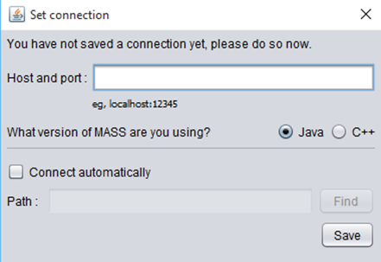
Figure 2: UI element that opens when the user starts the debugger for the first time.

The bottom right of the GUI features an element that tells the status of the connection with the MASS application. When the application is first started, it will read “Not Connected,” until the user clicks the connect button on the top right of the GUI. The connection status will read “Connected” if there are not problems connecting. Errors connecting are also reported here. The “Not Connected” and “Connected” status are shown in figure 3.

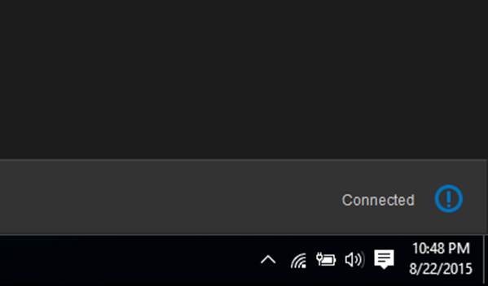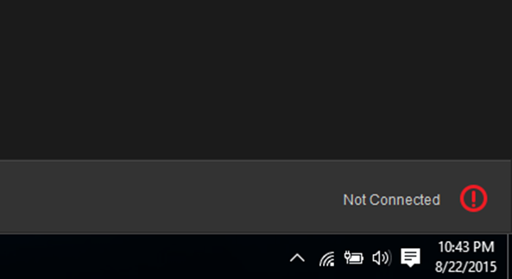
Figure 3: Connection statuses for “Not Connected” (Left) and “Connected” (Right).

The bottom left of the GUI features an element that allows the user to pause their MASS application and continue it. Clicking the pause symbol will pause the application, clicking the play symbol will resume the application until it finishes or is paused, and the skip symbol will advance the application one iteration if it is paused. This element is shown in figure 4.

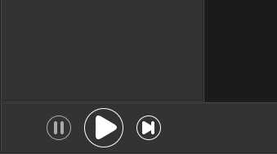
Figure 4: UI element for pausing, resuming, stepping forward once.

The UI element on the left shows the Place the user has most recently clicked on and the value associated with that Place the was returned from the getDebugData() function. It also shows the Agents currently residing on that Place, and the values associated with that Agent that are returned from the getDebugData() function. The blue arrow symbols appear if the setDebugData() functions have been overridden in the user Places and Agents. The user can put in their own values and click the arrow to set their new values into their application. This element is shown in figure 5.

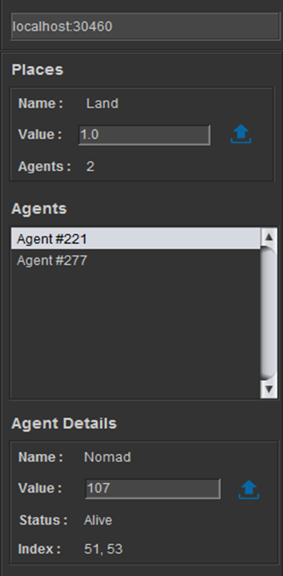
Figure 5: UI element showing the data in Places and Agents.

